**1.INTRODUCTION**

**1.1 OVERVIEW**

The following is a description of the individual parts of this structure. To ascertain the boundaries of water, the detecting layer simply collaborates with water tests conducted in dams, streams, or other similar environments. Similar to this, Wang et al. (2020) employed machine learning methods in a different investigation to find viruses in water samples. They suggested a feature selection technique for more precise RNA virus detection in water samples that integrated CNN and support vector machines (SVM) [1].

Many analytical methods have been put forth for the quick identification of microorganisms in water, and the effort of creating new and enhanced techniques for microbiological water analysis never stops. In recent times, biosensors have additionally been developed for the quick detection of microorganisms. Even fast, quantitative, and adaptable procedures like immuno-magnetic separation and flow cytometry.[2]

Water that is easily accessible and safe is essential for maintaining public health, irrespective of whether it is used for drinking, household chores, cooking, or leisure. Improved water resource management, along with better sanitation and water delivery, can significantly reduce poverty and accelerate economic growth in nations.[3]

**1.2 SENSING TECHNOLOGY**

1) Sensing Layer: It is developed squarely into an upward post labelled "sensor test" and comprises of several sensors packaged all in all. The variables measured could be temperatures, residual chloride, conductance, turbidity, pH, and many more. Very much like the ones given via Libelium [4]. Every technical insight that those sensors estimate are sent from the unit that sends them to the Haze Hubs (FNs), whether they are concerned or not. Along situations were installing detectors in the supply of water has exceptionally difficult as well as when obtaining the proper detectors isn't without problems, water boundary readings might be amassed from the connected water cure vegetation.

2) Edge Layer: The preceding layer requires entry-level handling devices referred to as angle modules, which could envelop single-board PC frameworks like Raspberry Pi or Nvidia Jetson, as well as microcontrollers prefer Arduino or ESP32.

These gadgets serve two number one capacities: i) as records pre-handling gadgets, liable for collecting, conglomerating, separating, and arranging information from the detecting layer, and ii) as local area gateways to transmit telemetry data through FNs that are via 3G/4G/5G cellular networks as well as other low-powered wide-area local area solutions.

3) Fog Nodes (FNs): Such devices are small, widely spaced networked computational centres designed to provide processing power and parking closer to the insights. Because of the transmission deferrals from the nearby to the distant cloud, this configuration reduces inertness [5]. Ordering water testing, using the framework, and gathering model data are all at FN's expense, which incorporates the ones proposed in this notice. Because of restricted figuring skills in contrast with the Cloud, just the greatest compelling boundaries are thought about all through water design type. This strategy decreases the requirement for some sensors, consequently requiring fewer figuring resources for the class cycle. Also, FN can adapt to help control, planning, and different obligations. In cases in which extensive term stockpiling or potentially complex calculations surpass the Haze's capacity, realities are sent to the Cloud records focus. Cloud Server farm: The Cloud addresses a distant, unreasonable exhibition processing foundation that proposals on-request figuring administrations [6]. In our framework, the Cloud capabilities as each a measurements vault and a stage for executing progressed information examination, making dashboards, and site facilitating relevant administrations and programming program.

4) Application Layer: Functions provides an extension between clients and programming programs and contributions running inside the cloud, which include water control governments, end clients, and numerous partners. Here, clients can get basic programming for adhering to water boundaries via web and cell stages.

**1.3 MACHINE LEARNING ANALYSIS**

**Supervised Learning**

The decision demonstrates that supervised reading has the life of a management in addition to that of an educator. Using well-categorized records, we teach or train the device at same time as mostly controlled discovery. This already has the fine reaction marked with a few data. Subsequently, a brand-new set of instances (statistics) is fed into the device so that the supervised learning set of rules evaluates the training statistics (set of training cases) and produces an appropriate output from the classed statistics.

**Unsupervised Learning**

Unmonitored discovery refers to teaching a computer using data that is neither identifiable nor recognized, and it also permits a collection of rules to act automatically on those records. In this instance, the system organizes unsorted data according to similarities, styles, and further distinctions without the need for prior record-keeping education. In contrast to supervised learning, no teacher is provided, implying that the maker will not receive any instruction. Consequently, the tool is limited in its ability to identify the hidden structure in unlabelled data on its own.

**1.4 ORGANIZATION OF THESIS**

**Chapter 2: LITERATURE SURVEY**

It includes a review of the literature along with a synopsis of several papers from journals like IEEE and Springer. The benefits and drawbacks of the current system have been thoroughly examined, and its shortcomings have been noted.

**Chapter 3: PROPOSED SYSTEM**

As covered in Chapter 2, techniques and algorithms were presented and explored in order to address the shortcomings of the current system and create the proposed system.

**Chapter 4: SYSTEM DESIGN**

The many aspects involved within the layout of the suggested system have been explained.

**Chapter 5: RESULTS AND DISCUSSIONS**

The implementation carried out in the preceding chapter produced the results, which were then extensively discussed.

**Chapter 6: CONCLUSION AND FUTURE ASPECTS**

The work's future aspects have been outlined, and an overview of the current work has been provided.

**1.5 SUMMARY**

The topics discussed in this chapter include both the project's fundamental concepts and an overview of the entire undertaking.

**2.LITERATURE SURVEY**

**2.1 OVERVIEW**

We go over a few books and authored articles on similar topics in this part. This section is separated into three primary components. The first one discusses the application of wireless networks for keeping an eye on water parameters. The standards for assessing the calibre of drinkable water come next, and research that look at the best way to decide whether water is suitable for irrigation conclude the list.

**2.2 ANALYSING WATER PARAMETERS**

**2.2.1 Water Monitoring using Wireless Communication Networks**

In a city that manufactures metals in Brazil, a network was set up to test and keep an eye on water parameters [7]. At twelve different monitoring locations, a wide range of physicochemical water qualities, such as pH and dissolved solids, zinc, lead, and others, were measured. Using principal component analysis on the gathered data was our final step. A comparable system for monitoring water quality was also put in place in the Limpopo River Basin of Mozambique [8], involving the installation of 23 monitoring stations to gather information on various physiochemical and microbiological parameters. The authors of [9] developed a financially viable model to address the issues related to constructing water monitoring systems, such as the optimal sites for gauges and sample frequencies, by combining a genetic algorithm with a one-dimensional water quality simulation. Even though the study was only simulated using a genetic algorithm, the authors were nonetheless able to tackle the NP-hard problem of optimally placing monitoring stations.

**2.2.2 Determine the Potability of Water**

Until recently, The Water Quality Index, often known as WQI, was the most trustworthy way to determine whether a water source was safe for human consumption. When deciding if water is fit for human consumption or other applications, this undefined value is employed. There are several methods available for computing WQI, and their suitability differs depending on environmental and geographic variables. A recent study by Uddin et al. [10] calculations indicating that approximately 35 water quality index (WQI) models in use worldwide. The Horton Index, the National Sanitation Foundation WQI, the CCME WQI in Canada, the SRDD index in Scotland, the Bascaron index (BWQI), the Fuzzy Interface system (FIS), and the MWQI in Malaysia, however, are the ones that the authors feel are the most significant. The models' structures, parameters, indexing and weighting standards, application regions, and limitations were all compared in the learning. For most of these models, a WQI score of fifty or more was considered adequate. In a similar spirit, [11] looked at a number of WQI models and highlighted the importance of the parameters. This study assigned weights to various qualities of water using the combination of the analytical hierarchical process (AHP) and the categorically based evaluation method (MACBETH). The most important characteristics were chosen according to their usage in the literature.

**2.2.3 Assessment of Irrigation Water Quality**

Irrigation water is essential to food production, especially when growing crops. A concerted effort is required to provide appropriate water quality standards because the condition of the water might affect agricultural output [12]. One of the many conventional methods for evaluating the quality of water that is comparable to drinking water quality is the irrigation water quality index (IWQI) [13]. Nevertheless, the majority of these techniques are either exclusive to drinking water or too costly for nearby farms to implement. Alternative ML-based techniques have been proposed by researchers; a few of these are listed in this section.

**2.2.4 Existing System**

In a city that manufactures metals in Brazil, a network was set up to test and keep an eye on water parameters [14]. At twelve different monitoring locations, the pH, dissolved solids, zinc, lead, and other physico-chemical water parameters were measured. For additional investigation, the data was subsequently put through principal component analysis. Similarly, the authors of [14] were able to assess the water quality in Mozambique's Limpopo River Basin by setting up 23 observational sites to measure physico-chemical and microbiological features. The authors of [15] developed a financially viable approach to address the issues related to constructing water monitoring systems, such as the optimal sites for gauges and sample frequencies, by combining a genetic algorithm with a one-dimensional water quality simulation. The NP-hard problem of where to locate monitoring stations was solved by the authors using simply a genetic algorithm for simulation.

Taking samples from a body of water at regular intervals to collect valuable metrics is a typical method for keeping an eye on water parameters. These measurements may include potential hydrogen (pH), temperature, salinity, and other physical, chemical, and microbiological characteristics. The necessary decision(s) in a water monitoring network can be made by the transmission of measured parameters to a base station. Water monitoring networks require lightweight communication techniques that can deliver little data over great distances due to the sparseness of the sent data. According to studies, Low Power Wide Area Networks are the most often utilized technologies for these kinds of applications, or LPWANs. In [16], the topic of LPWAN technology was thoroughly covered. This study examined a variety of sub-GHz solutions, including Sig-Fox, Lora, Ingenui, and Telensa, and compared their range, transmission rate, and channel count. With 10 km in cities and 50 km in rural areas, Sig Fox led the group; Ingenu followed at 15 km in urban settings; LoRa followed at 5 km in urban areas; and Sig Fox again came in at 15 km in rural regions.

Software simulations vs real-world testing has been a long-drawn dispute about the evaluation of communication technologies. The outcomes of simulations are often comparable to those of real-world testing, according to a number of academics, however this argument is far from over. In one such study, real-world the outcomes of the experiment were contrasted with simulations of intervehicle communication based on LoRa [17]. For the real-world testing, they employed an Arduino UNO C Dragino LoRa module and NS3 for the simulation. Packet delivery ratio (PDR), received signal strength indicator (RSSI), coverage packet inter-reception (PIR), and propagation loss were the metrics used as benchmarks. They concluded that the results of the simulator and the real testing agreed. Additionally, to ascertain how successfully LoRa functioned as a Wi-Fi bridge, they contrasted the outcomes of real-world trials employing micro controllers C LoRa modules with those of a radio mobile simulator. Despite the fact that the simulator functioned well, [18] did not, in contrast to [19], compare side-by-side the simulated and real-world outcomes for every statistic that was examined. To test the communication performance using the 800/900MHz and 2.4GHz frequencies, seven pairs of XBee modules were configured [20]. They deduced that there existed no difference in the outcomes between the Radio Mobile simulator and the actual testing.

**2.2.5 Disadvantages of Existing System**

* Effective SVM-style machine learning classifiers, RF, or NB are not used in the existing system.
* An extensive number of datasets are not supported by the current system.

**3.PROPOSED SYSTEM**

**3.1 OVERVIEW**

According to the suggested approach, the water's suitability for drinking is determined by measuring its bacterial and viral content. This technology uses cutting-edge microbial analysis technologies to identify 4e microbial pollutants. This involves employing next-generation sequencing (NGS) and polymerase chain reaction (PCR) to quantify and identify certain bacteria and viruses found in water sources.

**3.1.1 Logistic Regression Classifier**

Logistic regression will be taken into consideration, when the variable has two classes either 1 or 0 or else yes or no. if there are 3 or more distinct classes then it is called as multinomial logistic regression. It depends on the dataset weather it is LR or MLR, but the process and evaluation criteria will be same for both the types.

**3.1.2 Random Forest**

Random forest is utilised for classification, regression and for so many, so it is similarly called random decision forest. In the cataloguing training phase n number of decision trees were created and gives the best output based on most of the trees. It gives the overall prediction of the individual trees in the regression task. The output and result will be considered based on the data being analyzed. Third model is used as black box in n number of business applications because it gives matched predictions and with minimal requirements of configuration.

**3.1.3 Support Vector Machine**

From a training set, finding out the unbiased and discriminant function by using SVM. The classification function directly assigns an information factor X in the mission but which is less powerful than generative methods. In the multidimensional spaces, finding the probabilities are very critical. Classifier learning includes n number steps mainly figuring out the matching equation.

**3.2 PURPOSE**

Setting up a system to track and evaluate the irrigation water's quality and human use is critical for many reasons:

**3.2.1 Public Health Protection:**

Making sure the water utilized for drinking purposes meets regulatory standards for purity and safety is essential for safeguarding public health. Monitoring helps detect contaminants or pollutants that can be harmful to your health if consumes

**3.2.2 Safe Agricultural Practices:**

Water quality directly affects crop health and productivity. Using polluted water for irrigation lead to crop damage, reduced yields, or contamination of food products. Monitoring ensures that irrigation water meets quality standards to support healthy crop growth and minimize agricultural risks.

**3.2.3 Environmental Conservation:**

Monitoring water quality is vital for protecting aquatic ecosystems. Contaminants in water bodies can harm aquatic organisms, disrupt ecosystems, and degrade water quality for various uses. Assessing water quality helps identify sources of pollution and implement measures to mitigate environmental impacts.

**3.2.4 Resource Management:**

Effective water quality monitoring supports sustainable management of water resources. By tracking water quality parameters over time, authorities able to decide with knowledge regarding water allocation, usage priorities, and pollution control measures.

**3.3 SCOPE**

**3.3.1 Monitoring stations:**

Establishing a network of monitoring stations strategically located across the target area, such as watersheds, rivers, lakes, reservoirs, and groundwater sources. These stations should be equipped with sensors to measure various parameters including pH, turbidity, dissolve oxygen, temperature, conductivity, nutrient levels (nitrogen and phosphorus), heavy metal concentrations, and presence of pathogens.

**3.3.2 Data Collection and Transmission:**

Implementing a method for gathering information from monitoring stations in real-time or at regular intervals. This could involve satellite communication, wireless networks, or other telemetry systems to transmit data to a central database for storage and analysis.

**3.3.3 Water Quality Standards:**

Developing rules and regulations for the purity of the water, considering regional ordinances, global norms (such as the World Health Organization's recommendations for potable water), and unique farming needs.

* + 1. **Data Analysis and Interpretation:**

creating models and algorithms to estimate the gathered data and track changes in water quality over time. Statistical analysis might be required for this, machine learning techniques, and geospatial analysis to identify potential sources of pollution, seasonal variations, and areas of concern.

**3.4 OVERALL DESCRIPTION**

* **Product Perspective:**
* The system shall be capable of collecting information from a variety of sources including sensors, probes, and manual inputs.
* Temperature, turbidity, pH, and dissolved oxygen, conductivity, and pollutants including heavy metals and pesticides should all be comprised in the data collecting process.
* **Product Features:**

Indicators of water quality combined with pH, turbidity, temperature, conductivity, and pollutants like heavy metals and pesticides are monitored continually by the system.

* **Real-time Monitoring:**

Constantly checking the water for chemical pollutants, temperature, dissolved oxygen, turbidity, and pH levels.

* **Sensor Integration:**

Compatibility with various sensors for comprehensive water quality analysis, including conductivity sensors, spectrophotometers, and microbial sensors.

* **Data Visualization:**

User-friendly interface for visualizing water quality data in real-time, with customizable graphs, charts, and maps to easily interpret trends and anomalies.

* **Alert System:**

Automated alerts via email, SMS, or mobile application notifications to inform users about sudden changes or critical levels in water quality parameters, allowing for prompt response and intervention.

* **Historical Data Storage:**

Archiving past data on water quality for analysis, comparison, and trend identification, aiding in long-term monitoring and decision-making processes.

* **Remote Access:**

Ability to access and manage the system remotely through a secure web- based platform or mobile application, facilitating monitoring and control from anywhere with internet connectivity.

**3.4.1 User classes and characteristics:**

* **Water Utility Managers:**

Responsible for overseeing water treatment and distribution systems. Require comprehensive monitoring tools to ensure water quality meets regulatory standards. Need access to historical data for analysis and reporting purposes.

* **Farmers and Agricultural Workers:**

Need to monitor water quality to ensure it is suitable for crop growth and to prevent contamination. Require real-time alerts for any water quality issues that could affect crop health. May require integration with irrigation systems for automated water management.

* **Regulatory Agencies:**

Need access to water quality information gathered from multiple sources for regulatory compliance assessments. Require customizable reporting features to generate compliance reports. Prioritize accuracy, reliability, and transparency of data.

* **Sensor Integration:**

Water quality parameters may be continually monitored by the integration of multiple sensors, including pH, turbidity, dissolved oxygen, andtemperature sensors, which are strategically distributed throughout water sources.

* **Collection of data and Transmission:**

Automated gathering of sensor data at regular intervals and transmission of this data to a centralized database or server Using technologies for wireless communication, like Wi-Fi, cellular networks, or IoT protocols.

* **Data Visualization and Analysis**

User-friendly interfaces and dashboards for visualizing real-time and historic statistics on water quality parameters. Tools for analyzing and interpreting data trends, identifying anomalies, and generating insights.

* **Alerting and Notifications:**

Automated alerting mechanisms to notify relevant stakeholders (e.g., water authorities, farmers) in case of deviations from predefined water quality standards or thresholds. You may choose to get alerts by email, text message, or even your mobile app.

* **Remote Monitoring and Control:**

Possibility of controlling irrigation systems and water quality parameters remotely using web-based or mobile apps. Users are able to make well-informed judgments and take necessary actions from any location thanks to this functionality.

* **Historical Data Storage and Analysis:**

Storage of historical information on water quality for trend analysis, long-term monitoring, and retrospective analysis. This data can as well be utilized for research, policy-making, and infrastructure planning purposes.

**3.4.2 ADVANTAGES OF THE PROPOSED SYSTEM**

* Because LR is a supervised technique with high speed and accuracy, it is frequently employed for text categorization. Based on the training data, it creates a hyperplane, a two-dimensional line that most effectively divides the categories. This hyperplane is known as the decision boundary.
* Using the Bayes theorem, the Naive Bayes classifier [21] is a probabilistic method for classifying sample data.

**3.5 FEASIBILITY STUDY**

We evaluate the project's potential at this point and offer A business strategy that includes an approximate budget and an overview of the project's main objectives. An integral component of system analysis is evaluating the proposed system's viability. Our top goal is to guarantee that the recommended solution won't put undue financial strain on the company. Understanding the essential requirements of the structure at a fundamental level is required in order to conduct a feasibility study.

Three main elements are taken into account in the feasibility study:

* ECONOMICAL FEASIBILITY
* TECHNICAL FEASIBILITY
* SOCIAL FEASIBILITY

**3.5.1 Economical Feasibility**

The goal of this research is to evaluate the system's potential financial impact on the company. The company's budget for system development and research is constrained. Each expenditure needs to be justified. Because of this, the organization was constructed within budget, and the most of the technology employed are available to the general public. Purchasing only the customizable products was required.

**3.5.2 Technical Feasibility**

This overview focuses on the system's viability, or technological needs. No system that is developed should place an undue burden on the resources for technology that are now accessible. This will mean that the existing technological resources will be heavily utilized. The customer will feel a lot of pressure as a result. The planned system must have low need since it requires no or very little adjustments to be deployed.

**3.5.3 Social Feasibility**

Measuring the user's level of system satisfaction is the main goal of the study. In order to do this, the user must be taught how to maximize the technology. Users should view the system as a necessary tool rather than as an enemy. The methods employed to acquaint and inform the user about the system are the sole elements that dictate the extent of adoption among the users. As the last user of the system, he must be more at ease offering constructive criticism as feedback.

**3.6 HARDWARE & SOFTWARE REQUIREMENTS**

**3.6.1 Hardware Requirements:**

Hardware interfaces specify the logical characteristics of each interface between the software product and the hardware components of the system. The following are some hardware requirements.

* Processor - Pentium –IV
* RAM - 4 GB (min)
* Hard Disk - 20 GB
* Key Board - Standard Windows Keyboard
* Mouse - Two or Three Button Mouse
* Monitor - SVGA

**3.6.2 Software Requirements:**

Software Requirements specifies the logical characteristics of each interface and software components of the system. The following are some software requirements,

* Operating system : Windows 7 Ultimate.
* Coding Language : Python.
* Front-End : Python.
* Back-End : Django-ORM
* Designing : Html, CSS, JavaScript.
* Data Base : MySQL (WAMP Server).

**4.ARCHITECTURE DIAGRAM**

**4.1 PROJECT ARCHITECTURE**

This project architecture shows the procedure followed for classification, starting from input to final prediction.According to the suggested approach, the amount of bacteria and viruses in the water determined its quality. The output values of These two factors will decide whether the results are irrigation water or drinking water.

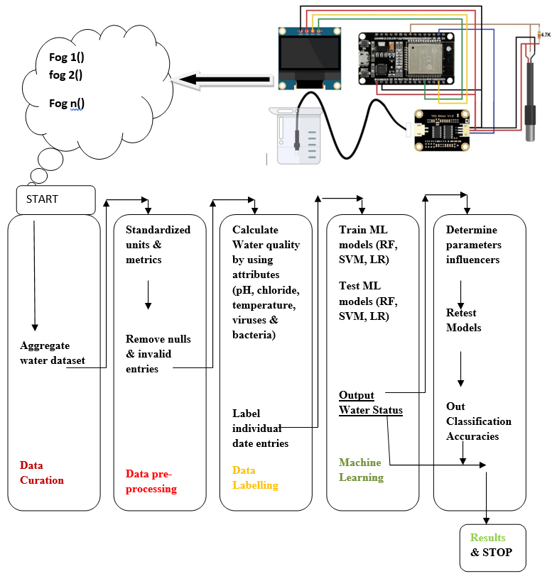

Figure 4.1: Project Architecture for Detecting of pathogens using Machine Learning Algorithms

**Description:** The study presents a unique approach to pathogen detection using machine learning integration, specifically focusing on water contamination detection. This method utilizes sophisticated algorithms and feature engineering to identify viruses and bacteria, addressing the increasing sophistication of traditional methods.

**4.2 USE CASE DIAGRAM**

A system for tracking and accessing water quality for use in agriculture and human consumption, the Water net Building a use case diagram for a network like "Water Net" requires breaking down the system into its individual components and cataloguing the interactions between each player.



Figure 4.2: Use Case Architecture for Detecting of pathogens using Machine Learning (ML)

**4.3 CLASS DIAGRAM**

A class diagram in software engineering is a kind of static structural diagram created using the UML that displays the classes, their attributes, methods, and relationships among the classes of a system. It shows which class the information is in.



Figure 4.3: Class Diagram for Detecting of pathogens using Machine Learning (ML)

**4.4 SEQUENCE DIAGRAM**

It is a form of interaction diagram used in the UML that shows the relationships and order how processes communicate with one another. It’s a build of a chart of message sequence. Event diagrams are another name for sequence diagrams, event scenarios, and timing diagrams.



Figure 4.4: Sequence Diagram for Detecting of pathogens using Machine Learning

**4.5 ACTIVITY DIAGRAM**

Workflows of sequential activities and actions with provision for choice, iteration, and concurrency are represented graphically using activity diagrams. Activity diagrams in the Unified Modeling Language can be used to walk viewers through the sequential business and operational workflows of system components. A diagram of activities depicts the entire control flow.

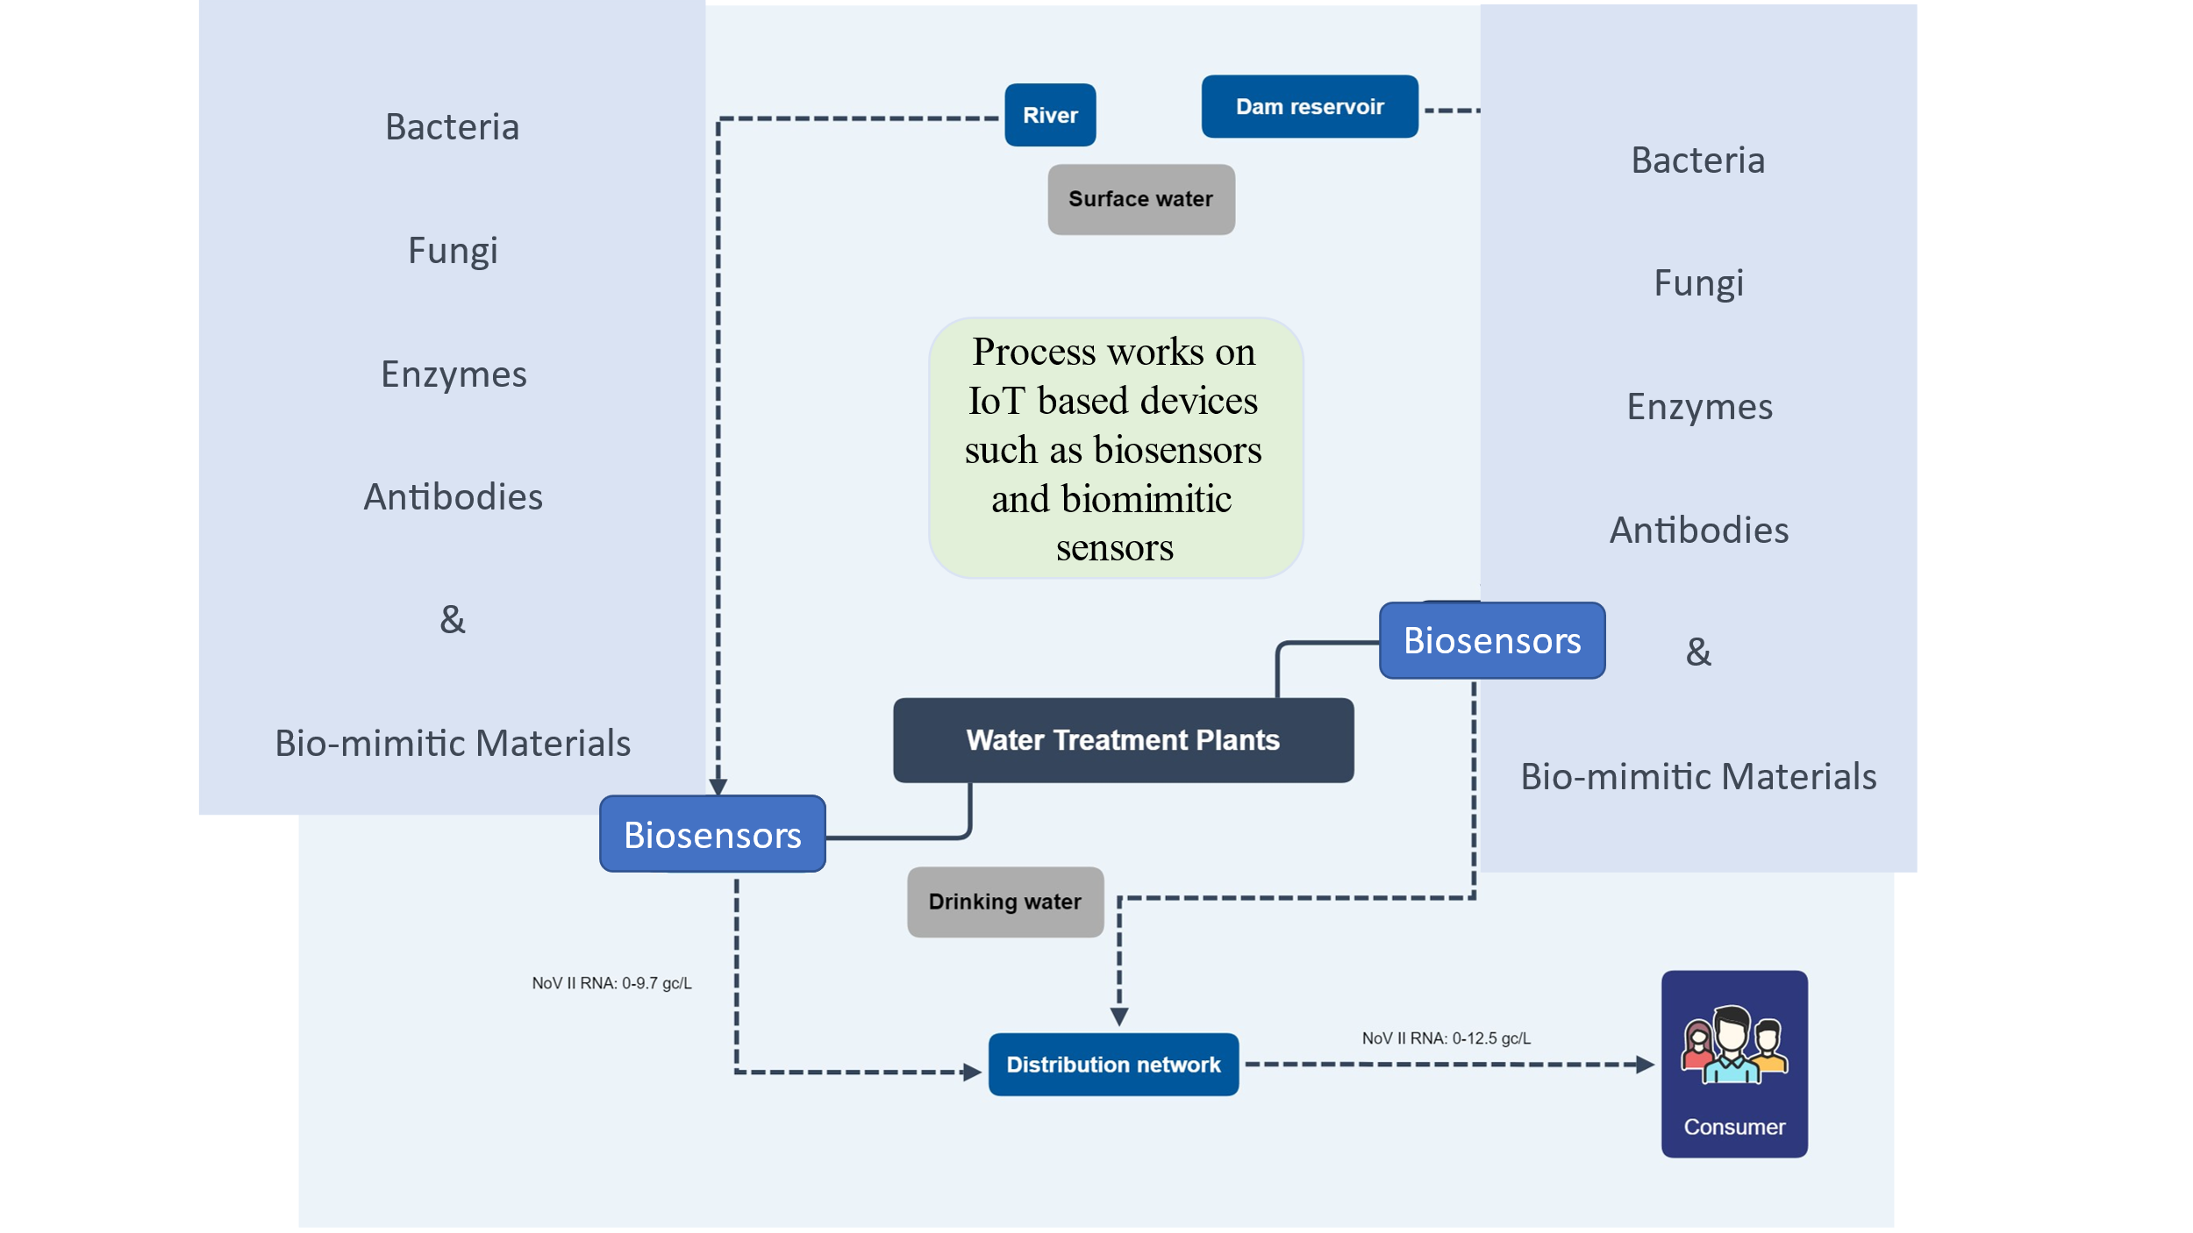

Figure 4.5 Activity Diagram for Detecting of pathogens using Machine Learning

**5. SYSTEM TESTING**

Testing aims to identify errors as well as any potential weaknesses or vulnerabilities in a work product. It offers a means of testing the functionality of separate components, assemblies, subassemblies, and/or last products. It’s a procedure for testing software to ensure that it meets the needs and expectations of the user and doesn't malfunction in an unacceptable way. Different test kinds exist. Every test type responds to a certain testing need.

**5.1 TYPES OF TESTS**

**5.1.1 Unit testing**

The development of designing unit testing test cases ensures that the core logic of the package is operating correctly, and that the program inputs result in legitimate outputs. Validation should be done on all internal code flows and decision branches. It is the examination of the application's separate software components. Before integration, it is completed following the conclusion of a single unit. This is an invasive structural test that requires structural knowledge. This evaluates a particular application, system configuration, or business process at the level of components. This provides assurance that every distinct path in a business processes function exactly in accordance with the specified requirements and have well-defined inputs and outputs.

**5.1.2 Integration testing**

Integration tests are designed to assess integrated software components to see whether they work together as a cohesive unit. Testing is event-driven and focuses mostly on the fundamental results of fields or screens. Integration tests verify that even though unit testing successfully shown that every element was satisfied alone, The parts are assembled with precision and consistency. Integration testing is done to find any problems that can arise from merging several components.

**5.1.3 Functional test**

Functional tests offer methodical proof that the functions being tested are available in accordance with the technical and business requirements, system documentation, and user manuals.

Focus of functional testing is on the following areas:

**Invalid in Input:** Certain sorts of input want to be disregarded.

**Functions:** Use of the assigned functions is required.

**Output:** It is essential to use the specified types of application outputs.

**Systems/Procedures:** It is necessary to invoke the interdependent systems or protocols.

**5.2 SYSTEM TEST**

System testing verifies that all requirements are met by the integrated software system as a whole. It puts a setup to the test in order to guarantee dependable outcomes. The configuration-oriented system integration test is an illustration of a system test. System testing emphasizes pre-driven process connections and integration points and is based on process flows and descriptions.

**6.EXPLORATORY DATA ANALYSIS**

**6.1 DATA ANALYSIS**

Many biosensors have been installed to sense different aspects of water with the intention of identify contaminated diseases and multiple variants of contaminants. Biomimetic sensors are recommended for online, continuous measuring methods. These sensors generate the data (pH (min/max), trihalome, bacteria, viruses, pH, sulphate, conductivity, solids, water, and others). The creation and verification of the use of prediction models is crucial for understanding and managing water quality in real time. The progress of prediction devices could also be helpful in ranking the sources of contaminants and figuring out the relative importance of the various elements that affect the quality of water at different geographic scales.

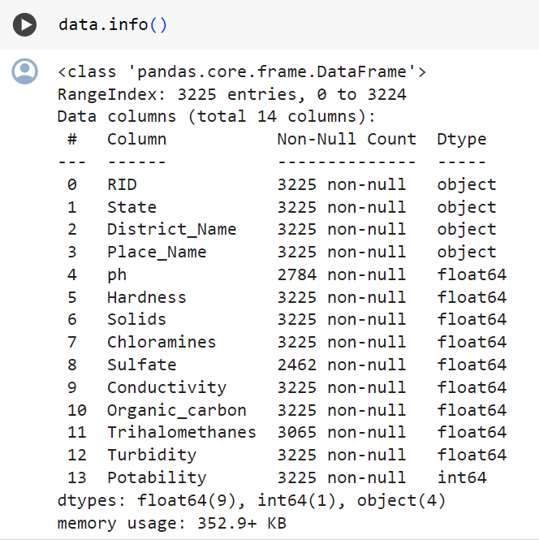

Table 6.1.1 Dataset of various attributes of water pathogens.

Models may additionally be employed to ascertain the probability that the concentration of a specific compound will be higher than allowed levels in drinking, agricultural, and recreational water. By facilitating the validation and verification of the model, the collection of real-time data reduces the uncertainty in the output. Predictive techniques can also become accustomed to map and forecast levels of pollution in the case of an accidental spill or other pollution incident. An early-warning system (EWS) has been developed that is revolutionary in its use of measurements of water effluent toxicity. In addition, the EWS uses biosensors to provide real-time measurements and a general warning is created upon pollutant detection. It is a multimodal technique for data detection, interpretation, analysis, and communication.

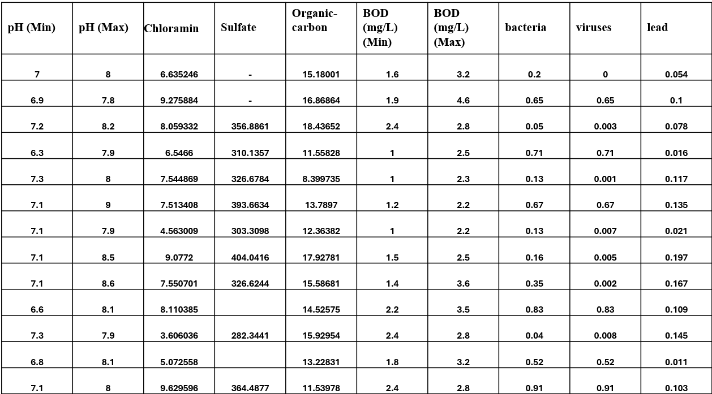

Table 6.1.2 Dataset of Drinking

Dataset of the project, It contains the 3276 instances with 10 features parameters of portable water for drinking are pH(min),pH(max) solids, chloramine, sulphate, Organic carbon, BOD(min), BOD(max), bacteria, virus, potability, turbidity, trihalome and other.

**Water Quality Parameters:**

* **pH Level:** The measure of acidity or alkalinity of the water.
* **Turbidity:** Water that is murky or discolored because of particles floating in it.
* **Dissolved Oxygen (DO):** Dissolved oxygen concentration, a necessary vitamin for all kinds of aquatic life.
* **Conductivity:** The ability of water to conduct electrical current, indicative of dissolved ions. A measure of the concentration of dissolved ions in water that is proportional to its electrical conductivity

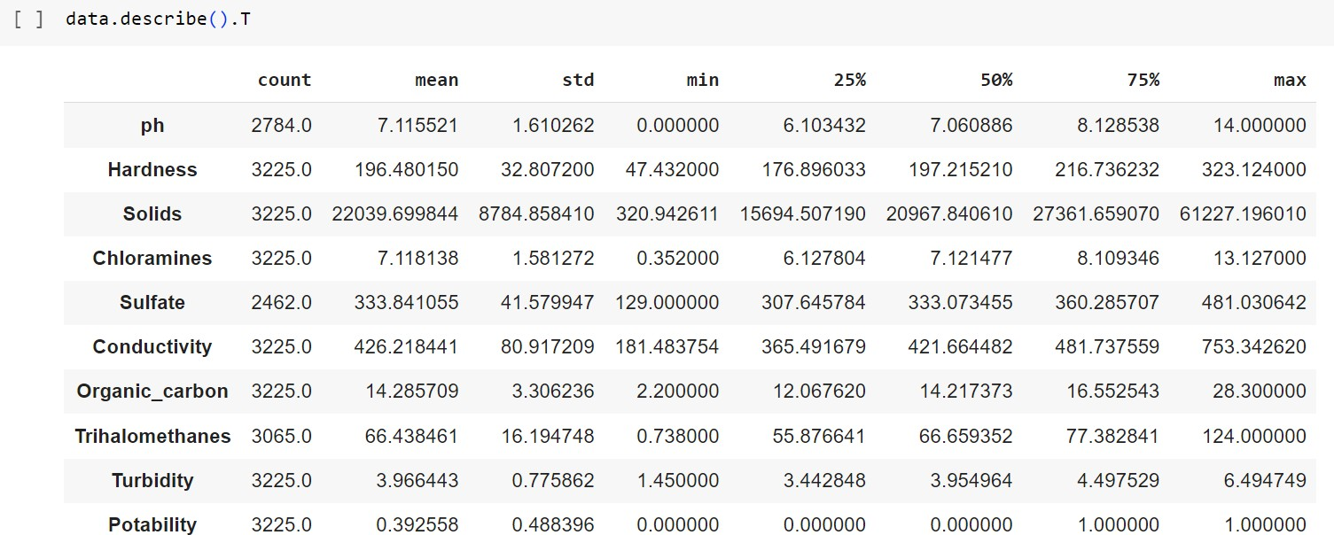

Table 6.1.3 Dataset of various attributes for irrigation

It contains the 3276 instances with 10 features of water parameters for irrigation are hardness, Ph(min/max), Biochemical oxygen demand (BOD) solids, chloramine, sulphate,

conductivity, bacteria, virus, potability, turbidity, trihalome and other.

**6.2 MEASURES**

**6.2.1 Random Forest:** Random Forest is also known as random decision forest since it is utilized for numerous purposes, including regression and classification. Many decision trees were constructed throughout the categorization training phase, and the optimal outcome was attained using the majority of the trees. In the regression task, it provides the overall forecast of each individual tree. The data being examined will determine the consideration of the output and result. Because the third model provides matching forecasts and requires little setting, it is utilized as a black box in many business applications.

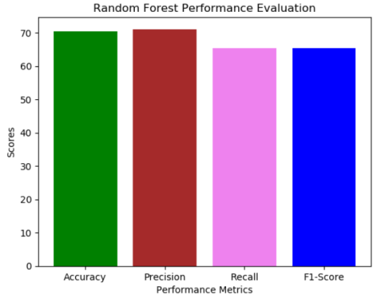

Fig 6.2.1. Random Forest Performance Evaluation

From figure.6.2.1, the RF is providing the performance evaluation s like accuracy is 71.21 percent, precision is 71.53 percent, recall is 66.79 and F1-score is 66.79 percent.

**6.2.2 SVM:** use SVM to determine the unbiased and discriminant function from a training set. Though less effective than generative approaches, the classification function directly assigns an information element X in the mission. It is crucial to find the probabilities in multidimensional spaces. Learning a classifier involves n numerical steps, primarily relating to matching equation computation.

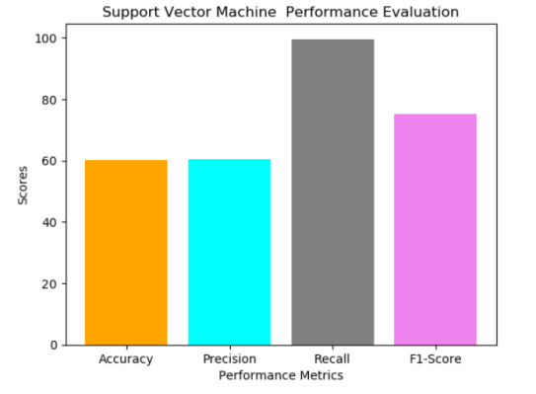

Figure 6.2.2. SVM Performance Evaluation

From figure.6.2.2, the SVM is providing the performance evaluations like accuracy is 60.29 percent, precision is 60.44 percent, recall is 99.59 and F1-score is 99.59 percent

**6.2.3 Logistic Regression Classifier:**

Logistic regression will be taken into consideration, when the variable has two classes either 1 or 0 or else yes or no. if there are 3 or more distinct classes then it is called as multinomial logistic regression. It depends on the dataset weather it is LR or MLR, but the process and evaluation criteria will be same for both the types.

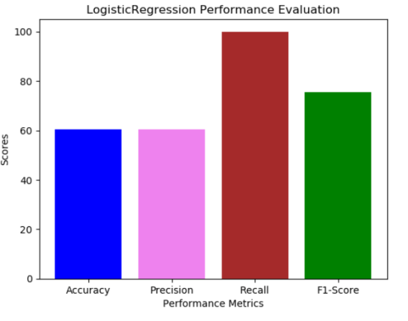

Figure 6.2.3. LR Performance Evaluation

From figure.6.2.3, the LR is providing the performance evaluations like accuracy is 60.54 percent, precision is 60.54 percent, recall is 100.00 and F1-score is 100.00 percent**.**

**7. SYSTEM DESIGN**

**7.1 DATA COLLECTION AND PRE-PROCESSING**

Collect a wide range of social media posts, especially those that include hate speech as well as those that do not. Remove any extraneous characters, emojis, or special symbols from the material before processing the data. Tokenization, stemming, and lemmatization can help you get to the root of words.

* **Extracting Features:**

Get useful information out of the textual information that has been preprocessed. Character embeddings, TF-IDF vectors, word embeddings (e.g., Word2Vec, GloVe), and pretrained language models (e.g., BERT) might all fit into this group . Take into consideration supplementary variables including user metadata (e.g., account age, follower count), temporal features (e.g., posting time), and social network features (e.g., likes, shares).

* **Model Selection and Training:**

You may try out several ML and DL models including BERT, LSTM, Support Vector Machines (SVM), Random Forest, and CNN. Apply cross-validation to the training set to fine-tune the hyperparameters. To avoid overfitting and guarantee generalizability, train the model on the training data and then test it on the validation set.

* **Model Evaluation:**

Remember to use appropriate measures such as recall, accuracy, precision, F1-score, and area under the ROC curve when evaluating the training model. Analyze model performance across different classes (hate speech vs. non-hate speech) and consider the implications of false. Perform error analysis to identify common misclassifications and areas for improvement.

* **Deployment and Integration:**

Deploy the trained model as a service accessible via an API. Integrate the hate speech detection service into social media platforms through partnerships or APIs provided by the platforms themselves Implement scalable infrastructure to handle large volumes of incoming data and user requests.

* **Monitoring and Continuous Improvement:**

Monitor the performance of the deployed model in real-time to detect drift and degradation. Collect user feedback and annotations to raise the standard of the training set of data and retrain the model periodically. Keep abreast with new developments in the field of evolving forms of hate speech to adapt the model accordingly.

* **Ethical Considerations:**

Implement measures to mitigate biases in the data and model predictions, such as fairness-aware training techniques and bias detection algorithms.

**7.2 MACHINE LEARNING ALGORITHMS**

**7.2.1 Decision tree classifiers:**

Decision tree classifiers perform effectively in many different domains. Their main characteristic is their capacity to take descriptive information from the provided data and use it for decision-making. Decision trees can be constructed with training sets. We will apply the following process with the objects (S) from the classes C1, C2,..., Ck in order to generate this set.

First, every leaf in S will have that class recognized if it’s a common class shared by all objects in S, such as Ci. Step Two. Let T then be a test, and the possible outcomes be O1, O2,..., On. The test divides set S into sets S1, S2,..., Sn, where each item in Si has the potential to have an Oi consequence for T, since there is only one conceivable outcome for T in set S. After T is configured as the decision tree root, we recursively call the same procedure on the set Si to create a child decision tree for every possible result Oi.

**7.2.2 A boost for gradients**

Gradient boosting is a machine learning (ML) method that has several uses, such as in regression analysis and classification. It builds its prediction models from an ensemble of less robust models, typically decision tree from two different places When a decision tree isn't doing well as a learner, the resulting method, called gradient-boosted trees, usually outperforms random forest. While other boosting approaches use a stage-wise construction, gradient-boosted trees enable optimization of any differentiable loss function, making them more versatile.

**7.2.3 K-Nearest Neighbors (KNN)**

One that is both easy to use and highly effective for categorization, K-Nearest Neighbors (KNN) uses a similarity metric to make its classifications.

"Learns" nothing until the test case is provided; this is known as non-parametric lazy learning.

Upon receiving new data for classification, we utilize the training set to determine its K-nearest neighbors.

Example

The instances that are closest to the training set in feature space are called k-closest.

Space having categorization variables, often known as non-metric variables, is called feature space. Instance-based learning is inherently slow since instances near for a considerable amount of time, the input vector for testing or prediction could not be found within the training batch of data.

**7.2.4 Regression based on logistic variables The classifiers:**

Collection of categorical dependent variables and a group of independent factors are compared using logistic regression. If two possible standards meant for the dependent variable, such as yes or no, logistic regression is the method that is utilized. In multinomial logistic regression, the dependent variable may have any of the following possible values: "Married," "Single," "Divorced," or "Widowed". The method's practical usefulness is similar to that of multiple regression, independent of the dependent variable's format. This software offers binary and multinomial methods for calculating logistic regression with numerical or categorical independent variables. The probability, deviance, odds ratios, confidence intervals, and quality of fit for the regression equation are all provided. It creates diagnostic residual reports and graphs as part of its extensive residual analysis. It is possible to find the best regression model with the fewest independent variables by using an independent variable subset selection search.

**7.2.5 Naïve Bayes:**

The supervised learning approach recognized as the naïve Bayes methodology everything on the premise that here is no correlation between the existence or lack of a certain class characteristic and any other attribute. The approach is predicated on this basic idea. Nevertheless, it appears powerful and efficient in spite of this. Its performance is equivalent to other supervised learning techniques. There have been numerous disputes put forth in the literature. This lesson emphasizes an explanation that is based on representation bias. In addition to logistic regression, linear SVM, and linear discriminant analysis, the naive Bayes classifier is a linear classifier (support vector machine). The discrepancy arises from the way the classifier's parameters are computed (the learning bias). Learning is very efficient, even on massive datasets, and it outperforms competing methods in terms of accuracy. However, end users don't get a model that's simple to comprehend and use, and they don't see the point of this approach.

One ensemble learning approach is the random forest, often called a random decision forest. It builds a large number of decision trees during training and uses them for classification, regression, and other tasks. The majority-chosen class in a classification challenge will be provided by the random forest.

Regression tasks return the mean or average forecast from all the trees. Random choice forests are an excellent remedy in cases where decision trees have a tendency to overfit their training set. Random forests frequently outperform choice trees, despite the fact that they aren't as accurate as gradient enhanced trees. However, the type of the data may affect how efficient they are. Using the random subspace technique, Tin Kam Ho created the first random decision forest algorithm in 1995 [1]. As Ho explains it, this technique allows one to implement Eugene Kleinberg's "stochastic discrimination" method of classification.

**7.2.6 Support Vector Machine:**

A discriminant machine learning approach, like support vector machines (SVMs), uses aid training dataset to generate a function of discrimination that can reliably forecast labels for newly acquired cases in classification tasks. Unlike methods for generative machine learning that call for building conditional probability distributions, discretant classification functions simply assign every information point x to each of the classes involved in the classification process. While generative methods are commonly used for outlier identification in predictions, discriminant methods are less efficient in this regard, even if they require less processing power and training.

**8. SOURCE CODE**

**8.1 SAMPLECODE**

rom django.db.models import Count, Avg

from django.shortcuts import render, redirect

from django.db.models import Count

from django.db.models import Q

import datetime

import xlwt

from django.http import HttpResponse

import nltk

import re

import string

from nltk.corpus import stopwords

from sklearn.feature_extraction.text import CountVectorizer

from nltk.stem.wordnet import WordNetLemmatizer

import pandas as pd

from wordcloud import WordCloud, STOPWORDS

from sklearn.feature_extraction.text import CountVectorizer

from sklearn.metrics import accuracy_score, confusion_matrix, classification_report

from sklearn.metrics import accuracy_score

from sklearn.metrics import f1_score

from sklearn.tree import DecisionTreeClassifier

from sklearn.ensemble import VotingClassifier

# Create your views here.

from Remote_User.models import ClientRegister_Model,assessing_water_quality,detection_ratio,detection_accuracy

def serviceproviderlogin(request):

if request.method == "POST":

admin = request.POST.get('username')

password = request.POST.get('password')

if admin == "Admin" and password =="Admin":

return redirect('View_Remote_Users')

return render(request,'SProvider/serviceproviderlogin.html')

def Find_Predicted_Water_Quality_Detection_Type_Ratio(request):

detection_ratio.objects.all().delete()

ratio = ""

kword = 'IRRIGATION WATER'

print(kword)

obj = assessing_water_quality.objects.all().filter(Q(Prediction=kword))

obj1 = assessing_water_quality.objects.all()

count = obj.count();

count1 = obj1.count();

ratio = (count / count1) * 100

if ratio != 0:

detection_ratio.objects.create(names=kword, ratio=ratio)

ratio1 = ""

kword1 = 'DRINKING WATER'

print(kword1)

obj1 = assessing_water_quality.objects.all().filter(Q(Prediction=kword1))

obj11 = assessing_water_quality.objects.all()

count1 = obj1.count();

count11 = obj11.count();

ratio1 = (count1 / count11) * 100

if ratio1 != 0:

detection_ratio.objects.create(names=kword1, ratio=ratio1)

obj = detection_ratio.objects.all()

return render(request, 'SProvider/Find_Predicted_Water_Quality_Detection_Type_Ratio.html', {'objs': obj})

def View_Remote_Users(request):

obj=ClientRegister_Model.objects.all()

return render(request,'SProvider/View_Remote_Users.html',{'objects':obj})

def ViewTrendings(request):

topic = assessing_water_quality.objects.values('topics').annotate(dcount=Count('topics')).order_by('-dcount')

return render(request,'SProvider/ViewTrendings.html',{'objects':topic})

def charts(request,chart_type):

chart1 = detection_ratio.objects.values('names').annotate(dcount=Avg('ratio'))

return render(request,"SProvider/charts.html", {'form':chart1, 'chart_type':chart_type})

def charts1(request,chart_type):

chart1 = detection_accuracy.objects.values('names').annotate(dcount=Avg('ratio'))

return render(request,"SProvider/charts1.html", {'form':chart1, 'chart_type':chart_type})

def View_Predicted_Water_Quality_Detection_Type(request):

obj =assessing_water_quality.objects.all()

return render(request, 'SProvider/View_Predicted_Water_Quality_Detection_Type.html', {'list_objects': obj})

def likeschart(request,like_chart):

charts =detection_accuracy.objects.values('names').annotate(dcount=Avg('ratio'))

return render(request,"SProvider/likeschart.html", {'form':charts, 'like_chart':like_chart})

def Download_Predicted_DataSets(request):

response = HttpResponse(content_type='application/ms-excel')

# decide file name

response['Content-Disposition'] = 'attachment; filename="Predicted_Data.xls"'

# creating workbook

wb = xlwt.Workbook(encoding='utf-8')

# adding sheet

ws = wb.add_sheet("sheet1")

# Sheet header, first row

row_num = 0

font_style = xlwt.XFStyle()

# headers are bold

font_style.font.bold = True

# writer = csv.writer(response)

obj = assessing_water_quality.objects.all()

data = obj # dummy method to fetch data.

for my_row in data:

row_num = row_num + 1

ws.write(row_num, 0, my_row.RID, font_style)

ws.write(row_num, 1, my_row.State, font_style)

ws.write(row_num, 2, my_row.District_Name, font_style)

ws.write(row_num, 3, my_row.Place_Name, font_style)

ws.write(row_num, 4, my_row.ph, font_style)

ws.write(row_num, 5, my_row.Hardness, font_style)

ws.write(row_num, 6, my_row.Solids, font_style)

ws.write(row_num, 7, my_row.Chloramines, font_style)

ws.write(row_num, 8, my_row.Sulfate, font_style)

ws.write(row_num, 9, my_row.Conductivity, font_style)

ws.write(row_num, 10, my_row.Organic_carbon, font_style)

ws.write(row_num, 11, my_row.Trihalomethanes, font_style)

ws.write(row_num, 12, my_row.Turbidity, font_style)

ws.write(row_num, 13, my_row.Prediction, font_style)

wb.save(response)

return response

def Train_Test_DataSets(request):

detection_accuracy.objects.all().delete()

data = pd.read_csv("water_datasets.csv")

def apply_results(results):

if (results == 0):

return 0 # Irrigation Water

elif (results == 1):

return 1 #Drinking Water

data['Label'] = data['Potability'].apply(apply_results)

x = data['Place_Name']

y = data['Label']

cv = CountVectorizer()

x = cv.fit_transform(x)

models = []

from sklearn.model_selection import train_test_split

X_train, X_test, y_train, y_test = train_test_split(x, y, test_size=0.20)

X_train.shape, X_test.shape, y_train.shape

print("Naive Bayes")

from sklearn.naive_bayes import MultinomialNB

NB = MultinomialNB()

NB.fit(X_train, y_train)

predict_nb = NB.predict(X_test)

naivebayes = accuracy_score(y_test, predict_nb) * 100

print(naivebayes)

print(confusion_matrix(y_test, predict_nb))

print(classification_report(y_test, predict_nb))

models.append(('naive_bayes', NB))

detection_accuracy.objects.create(names="Naive Bayes", ratio=naivebayes)

# SVM Model

print("SVM")

from sklearn import svm

lin_clf = svm.LinearSVC()

lin_clf.fit(X_train, y_train)

predict_svm = lin_clf.predict(X_test)

svm_acc = accuracy_score(y_test, predict_svm) * 100

print(svm_acc)

print("CLASSIFICATION REPORT")

print(classification_report(y_test, predict_svm))

print("CONFUSION MATRIX")

print(confusion_matrix(y_test, predict_svm))

models.append(('svm', lin_clf))

detection_accuracy.objects.create(names="SVM", ratio=svm_acc)

print("Logistic Regression")

from sklearn.linear_model import LogisticRegression

reg = LogisticRegression(random_state=0, solver='lbfgs').fit(X_train, y_train)

y_pred = reg.predict(X_test)

print("ACCURACY")

print(accuracy_score(y_test, y_pred) * 100)

print("CLASSIFICATION REPORT")

print(classification_report(y_test, y_pred))

print("CONFUSION MATRIX")

print(confusion_matrix(y_test, y_pred))

models.append(('logistic', reg))

detection_accuracy.objects.create(names="Logistic Regression", ratio=accuracy_score(y_test, y_pred) * 100)

print("Decision Tree Classifier")

dtc = DecisionTreeClassifier()

dtc.fit(X_train, y_train)

dtcpredict = dtc.predict(X_test)

print("ACCURACY")

print(accuracy_score(y_test, dtcpredict) * 100)

print("CLASSIFICATION REPORT")

print(classification_report(y_test, dtcpredict))

print("CONFUSION MATRIX")

print(confusion_matrix(y_test, dtcpredict))

models.append(('DecisionTreeClassifier', dtc))

detection_accuracy.objects.create(names="Decision Tree Classifier", ratio=accuracy_score(y_test, dtcpredict) * 100)

print("KNeighborsClassifier")

from sklearn.neighbors import KNeighborsClassifier

kn = KNeighborsClassifier()

kn.fit(X_train, y_train)

knpredict = kn.predict(X_test)

print("ACCURACY")

print(accuracy_score(y_test, knpredict) * 100)

print("CLASSIFICATION REPORT")

print(classification_report(y_test, knpredict))

print("CONFUSION MATRIX")

print(confusion_matrix(y_test, knpredict))

models.append(('KNeighborsClassifier', kn))

detection_accuracy.objects.create(names="KNeighborsClassifier", ratio=accuracy_score(y_test, knpredict) * 100)

print("SGD Classifier")

from sklearn.linear_model import SGDClassifier

sgd_clf = SGDClassifier(loss='hinge', penalty='l2', random_state=0)

sgd_clf.fit(X_train, y_train)

sgdpredict = sgd_clf.predict(X_test)

print("ACCURACY")

print(accuracy_score(y_test, sgdpredict) * 100)

print("CLASSIFICATION REPORT")

print(classification_report(y_test, sgdpredict))

print("CONFUSION MATRIX")

print(confusion_matrix(y_test, sgdpredict))

models.append(('SGDClassifier', sgd_clf))

detection_accuracy.objects.create(names="SGD Classifier", ratio=accuracy_score(y_test, sgdpredict) * 100)

print("Random Forest Classifier")

from sklearn.ensemble import RandomForestClassifier

rf_clf = RandomForestClassifier()

rf_clf.fit(X_train, y_train)

rfpredict = rf_clf.predict(X_test)

print("ACCURACY")

print(accuracy_score(y_test, rfpredict) * 100)

print("CLASSIFICATION REPORT")

print(classification_report(y_test, rfpredict))

print("CONFUSION MATRIX")

print(confusion_matrix(y_test, rfpredict))

models.append(('RandomForestClassifier', rf_clf))

detection_accuracy.objects.create(names="Random Forest Classifier", ratio=accuracy_score(y_test, rfpredict) * 100)

obj = detection_accuracy.objects.all()

return render(request,'SProvider/Train_Test_DataSets.html', {'objs': obj})

**9. OUTPUT SCREENS**

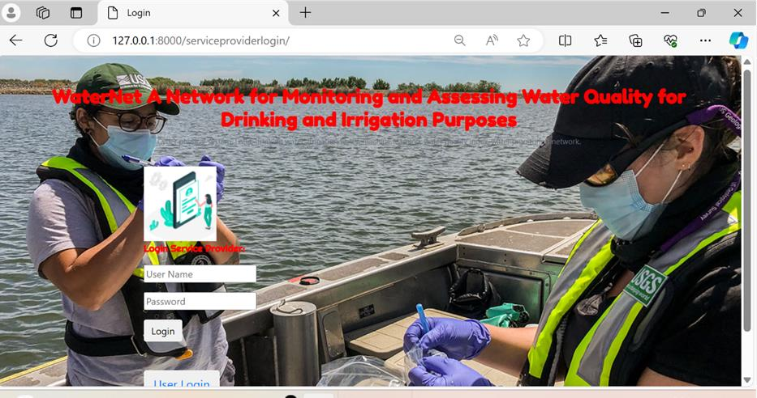**9.1 Admin Login Page:**

**9.2 Login Page:**

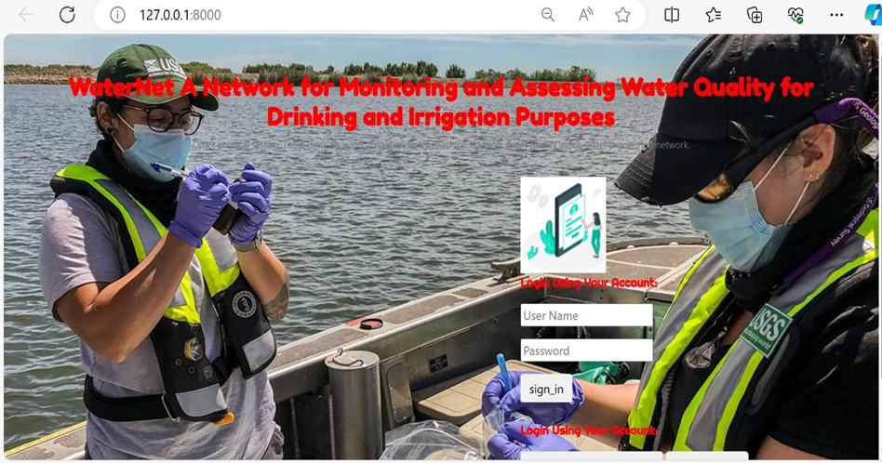

**9.3 Registration Page:**

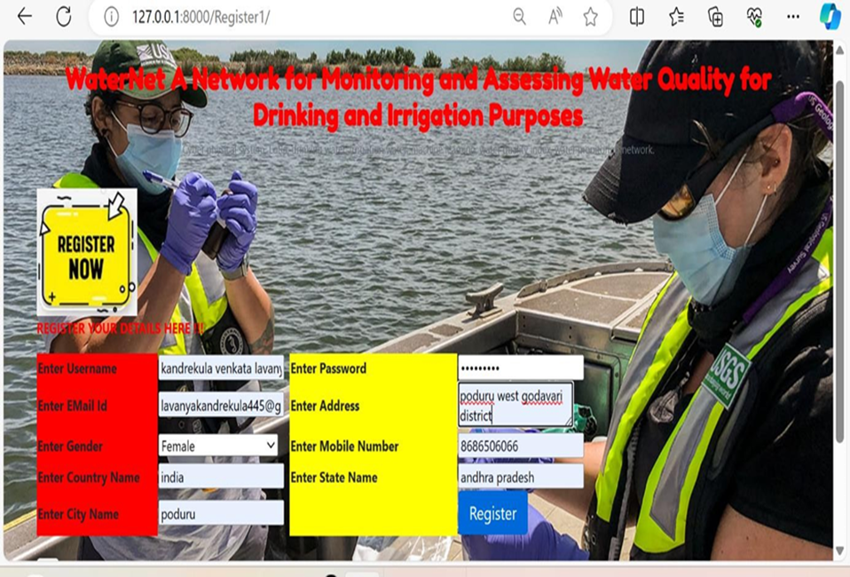

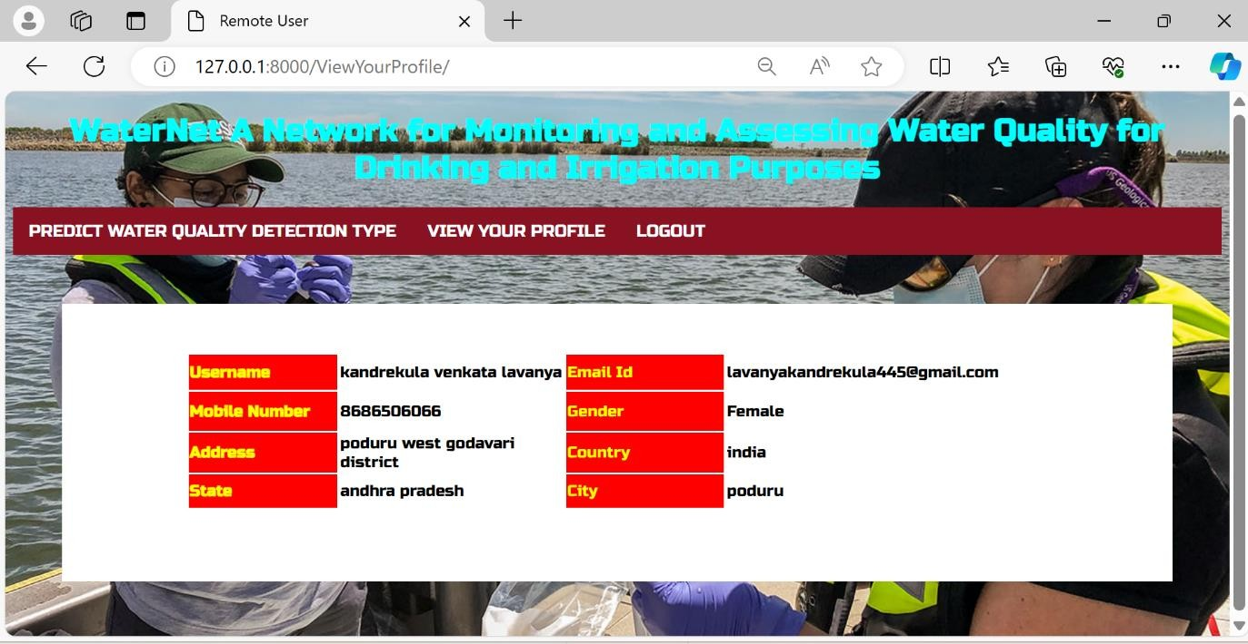**9.4 User Profile:**

**9.5 All Remote Users:**

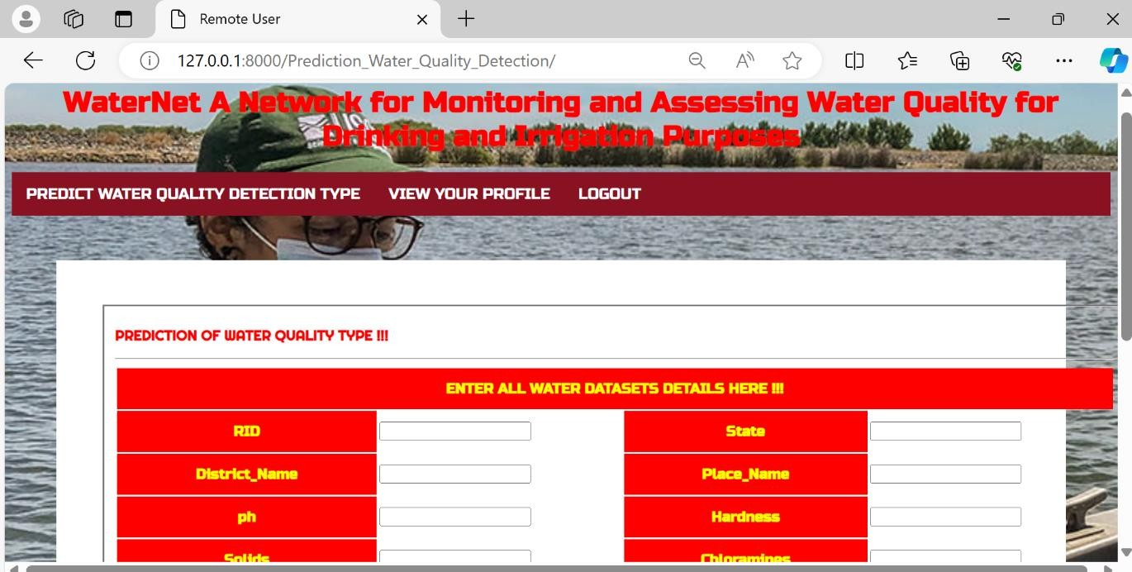

**9.6 Water Quality Prediction:**

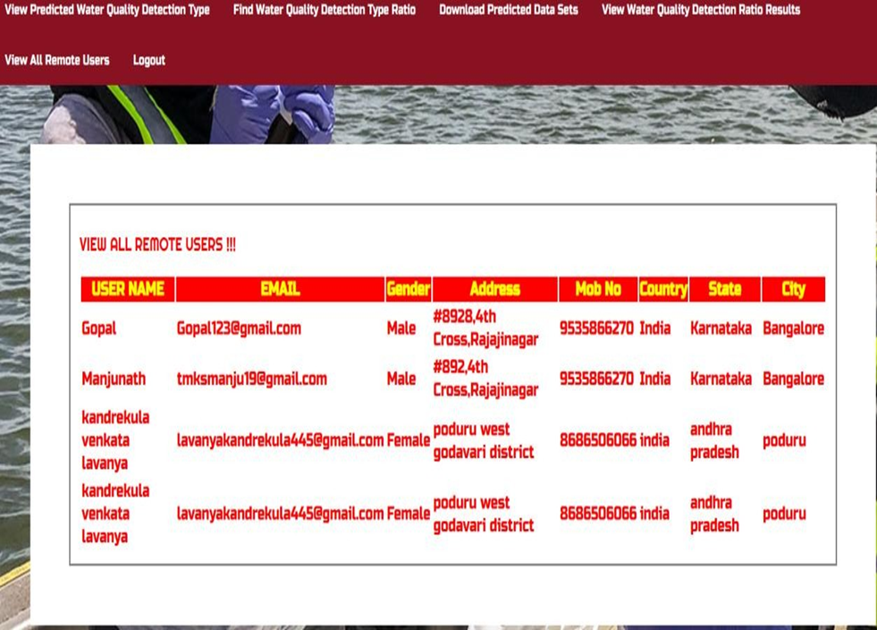**9.7 Water Quality statistical Data:**

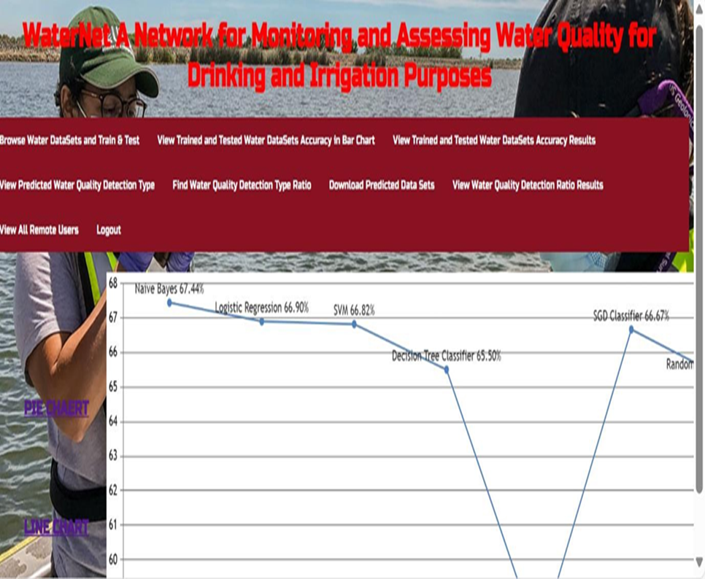

**9.8 Visualizing the Accuracy:**

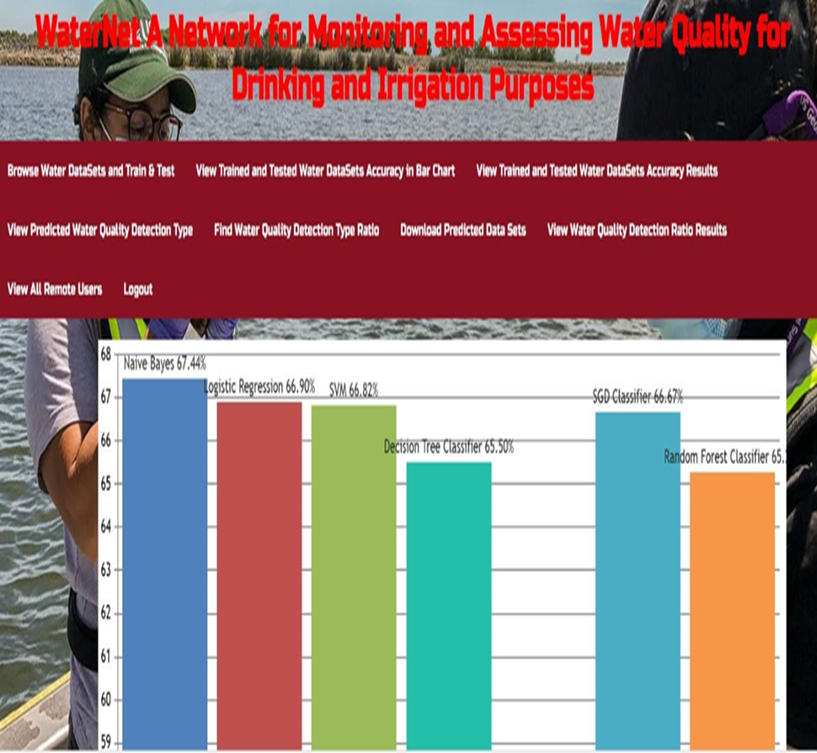

**10. CONCLUSION**

The work's initial central concept was the suggestion of a real-time water monitoring network to collect information on water parameters from bodies of water. Second, machine learning (ML) models’ usage to estimate the quality of the water. The City of Cape Town was used as a case study in the development of the water monitoring network, which is based on Lo Ra, a low power long range protocol for data transmission. Based on the results of the simulation conducted in Radio Mobile, a partial mesh network design was discovered to be the most suitable for covering the metropolis. In an ideal world, information from this monitoring network would be combined on a cloud server, allowing machine learning models to be used to evaluate whether the water is fit for irrigation or drinking. Since there were no pertinent datasets available, three machine learning models were considered for this investigation: Random Forest (RF), Logistic Regression (LR), and Support Vector Machine (SVM). Two suitable datasets were produced for the purpose of this research and used for the development and evaluation of the models. The test's findings showed that SVM was a better choice for irrigation water, whereas LR worked best for drinking water due to its maximum classification accuracy and lowest false positive and negative values. Lastly, a model for determining the water parameter or parameters which have greatest influence on the ML models' the accuracy of classification was examined using recursive feature elimination (RFE). The data obtained indicated that SSP had the least impact on irrigation water, whereas pH and overall hardness had the least impact on drinking water.

Although deep learning models are acknowledged by the authors as though possibly helpful, they weren't employed in this study. Future research could expand on this work by utilizing deep learning models, such as other neural network versions. Additionally, the "fitness for use" of estimated with water quality indices that were manually computed. Future research could investigate the use of unsupervised machine learning models in place of the manual calculation of water quality indices. Similarly, alternative methods like multicriteria decision making could be taken into consideration in place of RFE in order to determine influential parameters. Lastly, detecting the sources of water contamination and integrating microbiological monitoring and usage prediction models into the water network could also be ways to further this work.

**10.1 FUTURE SCOPE**

The sole goal of this investigation was to increase the accuracy of the outcomes derived from the various data generators (sensors). In this investigation, we focused on removing bacteria and viruses that contaminate water parameters in order to improve the quality of the water for irrigation and drinking. By removing impurities from water to use for different purposes, humans can maintain excellent health. Here, we used a range of methods and the dynamic datasets to increase the accuracy outcomes. Furthermore, in our investigation, only dynamic datasets were used.

**11.BIBILIOGRAPHY**

**11.1 REFERENCES**

1. Wang, Y., Qin, Y., Wang, Y., Zhang, J., & Li, Y. (2020). Detection of harbored viruses from water sources for viral risks from food consumption. Food Control, 118, 107370.
2. Bonadonna, Lucia & Briancesco, Rossella & Rosa, Giuseppina. (2019). Innovative analytical methods for monitoring microbiological and virological water quality. Microchemical Journal. 150. 104160. 10.1016/j.microc.2019.104160.
3. WHO. Water. Protection of the Human Environment. Accessed: Jan 24, 2022. www.afro.who.int/health-topics/water [Online]. Available:
4. Libelium.com. IoT Solution for Water Management. Accessed: Jan. 27, 2022. [Online]. Available: https://www.libelium.com/iot-solutions/smart-water/
5. K. Ma, A. Bagula, C. Nyirenda, and O. Ajayi, "An IoT- based fog computing model," Sensors, vol. 19, no. 12, p. 2783, Jun. 2019.
6. I.Odun-Ayo, O. Ajayi, and A. Falade, "Cloud computing and quality of service: Issues and developments," in Proc. Int. Multi-Conf. Eng. Compute Scientists (IMECS 2018), Hong kong, Mar. 2018, pp. 14_16.
7. A.R. Finotti, R. Finkler, N. Susin, and V. E. Schneider, Use of water quality index as a tool for urban water resources management," Int. J. Sustain. Develop. Planning, vol. 10, no. 6, pp. 781 794, Dec. 2015.
8. M. Chilundo, P. Kelderman, and J. H. O'keeffe, "Design of a water quality monitoring network for the limpopo river basin in Mozambique, Phys. Chem. Earth, A/B/C, vol. 33, nos. 8 13, pp. 655 665, Jan. 2008.
9. M. Karamouz, M. Karimi, and R. Kerachian, "Design of water quality monitoring network for river systems," in Critical Transitions in Water and Environmental Resources Management. London, U.K.: IWA, 2004, pp. 1_9.
10. M. G. Uddin, S. Nash, and A. I. Olbert, "A review of water quality index models and their use for assessing surface water quality," Ecolog. Indicators, vol. 122, Mar. 2021, Art. no. 107218.
11. N. Akhtar, M. I. S. Ishak, M. L. Ahmad, K. Umar, M. S. Md Yusuff, M. T. Anees, A. Qadir, and Y. K. A. Almanasir, "Modi cation of the water quality index (WQI) process for simple calculation using the multicriteria decision-making (MCDM)method: A review," Water, vol. 13, no. 7, p. 905, Mar.2021.
12. Shayo, G. M., Elimbinzi, E., & Shao, G. N. (2024). Water-based technologies for improving water quality at the point of use: A review. WIREs Nanomedicine and Nanobiotechnology, 16(1), e1940. https://doi.org/10.1002/wnan.1940
13. S.S, R. Moon, M. Umer, K. S. Raju, N. Bhaskar, and R. Okali, “A Prediction of Water Quality Analysis Using Machine Learning,” pp.1–6,Jun.2023,doi:10.1109/ICDCECE57866.2023.10150940.
14. T. Banda and M. Kumarasamy, "Development of a universal water quality index (UWQI) for South African river catchments," Water, vol. 12, no. 6, p. 1534, May 2020.
15. Wen X, Chen F, Lin Y, Zhu H, Yuan F, Kuang D, Jia Z, Yuan Z. Microbial Indicators and Their Use for Monitoring Drinking Water Quality—A Review. Sustainability. 2020; 12(6):2249.
16. U. Raza, P. Kulkarni, and M. Sooriyabandara, "Low power wide area networks: An overview," IEEE Commun. Surveys Tuts., vol. 19, no. 2, pp. 855_873, 2nd Quart., 2017.
17. F. M. Ortiz, T. T. de Almeida, A. E. Ferreira, and L. H. M. K. Costa, "Experimental vs. simulation analysis of LoRa for vehicular communications," Comput. Commun., vol. 160, pp. 299 310, Jul. 2020.
18. H. A. Aden and K. R. Karlsson, "Evaluating LoRa physical as a radio link technology for use in a remote- controlled electric switch system for a network bridge radio- node," M.S. thesis, Dept. Elect. Eng., School Elect. Eng. Comput. Sci., KTH Royal Inst. Technol., Stockholm, Sweden, 2018.
19. M. Zennaro, A. Bagula, D. Gascon, and A. B. Noveleta, "Long distance wireless sensor networks: Simulation vs reality," in Proc. 4th ACM Workshop Netw. Syst. Developing Regions (NSDR), 2010, pp. 1_2.
20. M. F. Howladar, M. A. Al Numanbakth, and M. O. Faruque, An application of water quality index (WQI) and multivariate statistics to evaluate the water quality around Maddhapara granite mining industrial area, Dinajpur, Bangladesh," Environ. Syst. Res., vol. 6, no. 1, pp. 1 8, Jan. 2018
21. A.R. Finotti, N. Susin, R. Finkler, M. D. Silva, and V. E. Schneider, "Development of a monitoring network of water resources in urban areas as a support for municipal environmental management." WIT Trans. Ecol. Environ., vol. 182, pp. 133 143, May 2014.

**11.2 GitHub link:** [**https://github.com/raj4sid/THALUKA-MOHAN-RAJ.git**](https://github.com/raj4sid/THALUKA-MOHAN-RAJ.git)